**How to add GitHub project to eclipse:**

**Topics will cover:**

1. How to create GitHub repository
2. How to clone repository in eclipse
3. How to add eclipse project to GitHub repository
4. How to commit, push & pull the changes
5. **How to create GitHub repository:**
6. Login into<https://github.com/>
7. Create account and sigin into

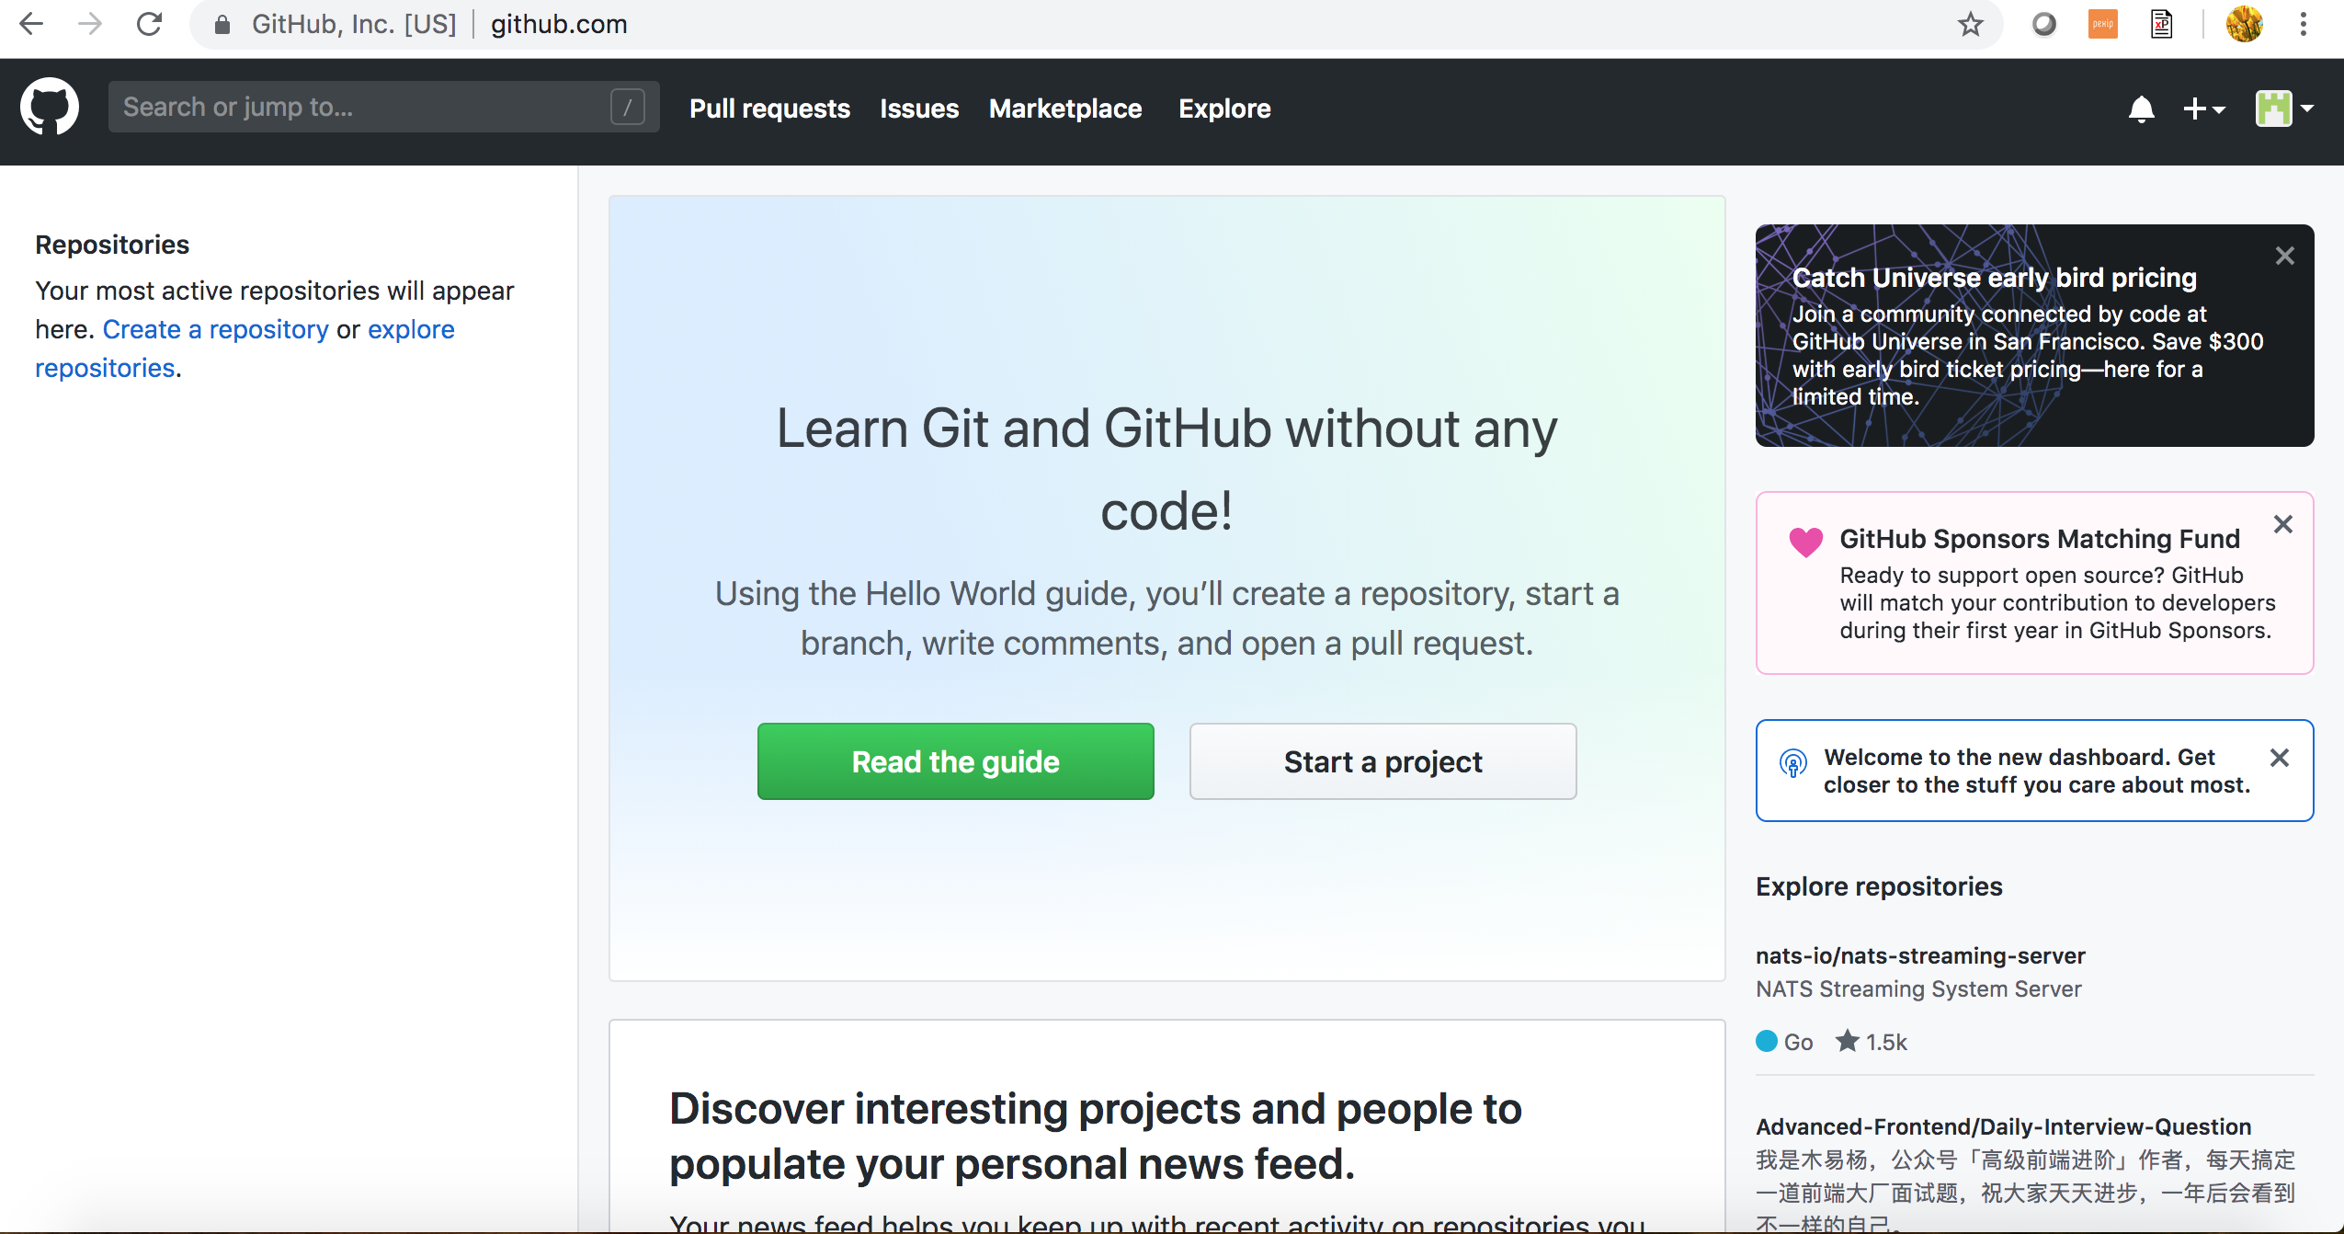

1. Start a project == creating a repository

Click on start a project and given project name and click on create repository

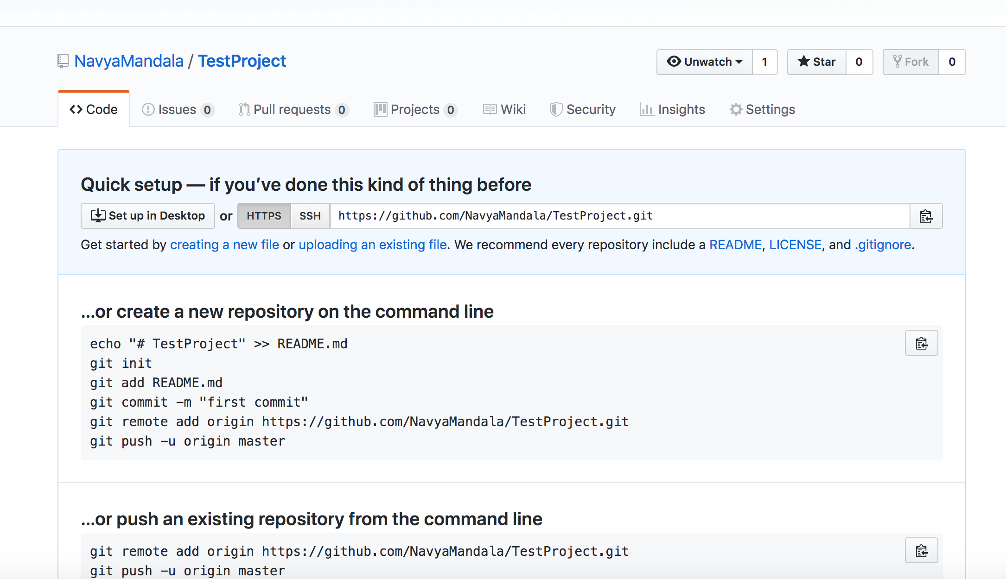

1. Start eclipse
2. Type Git Repositories->

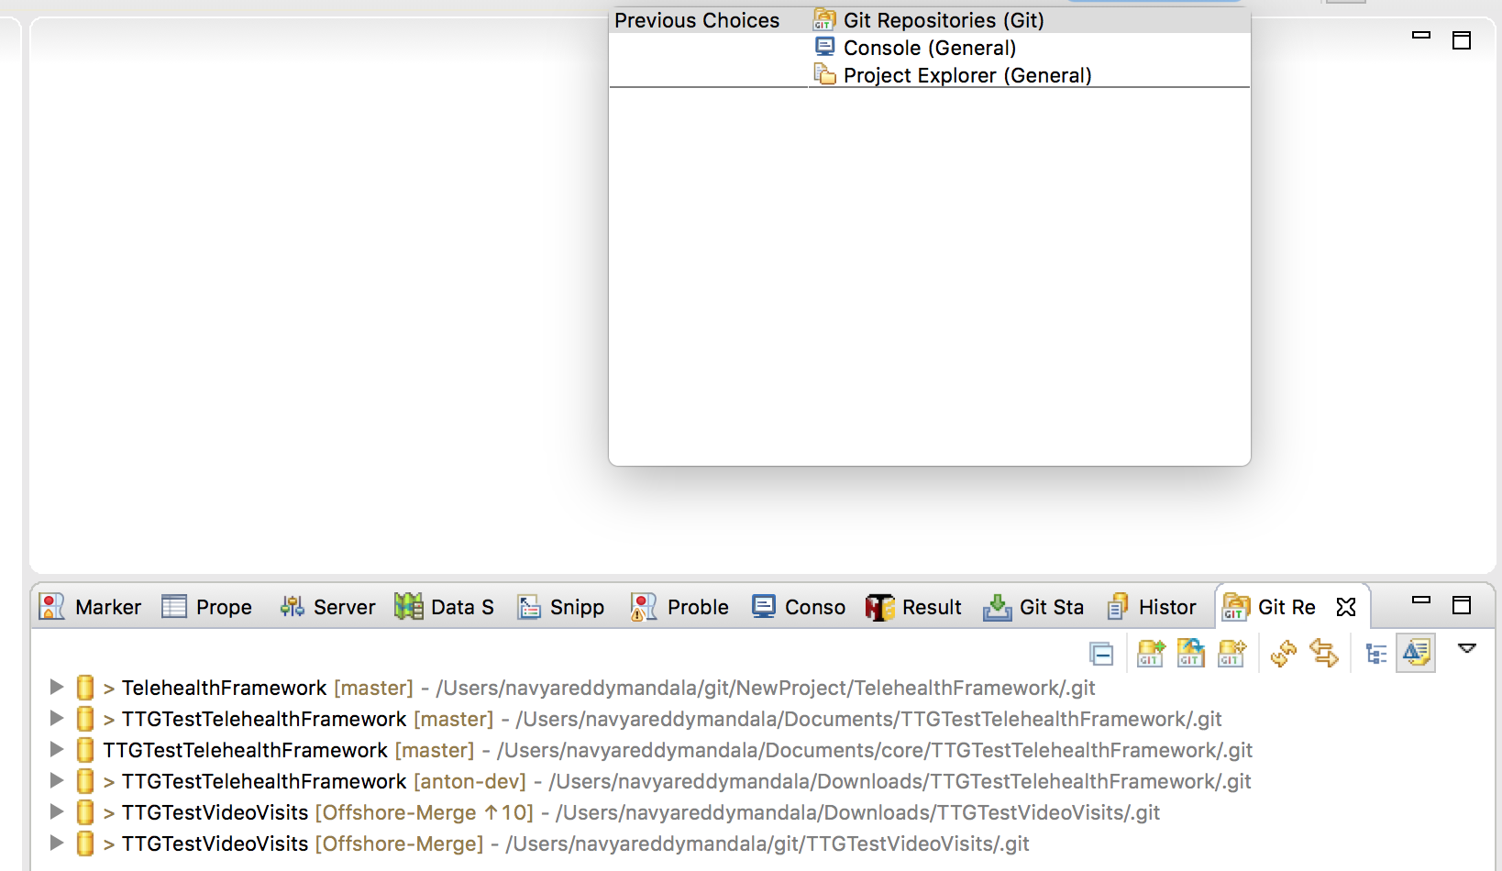

In this click on git clone🡪 3rd icon

And enter all the details copy the url from github

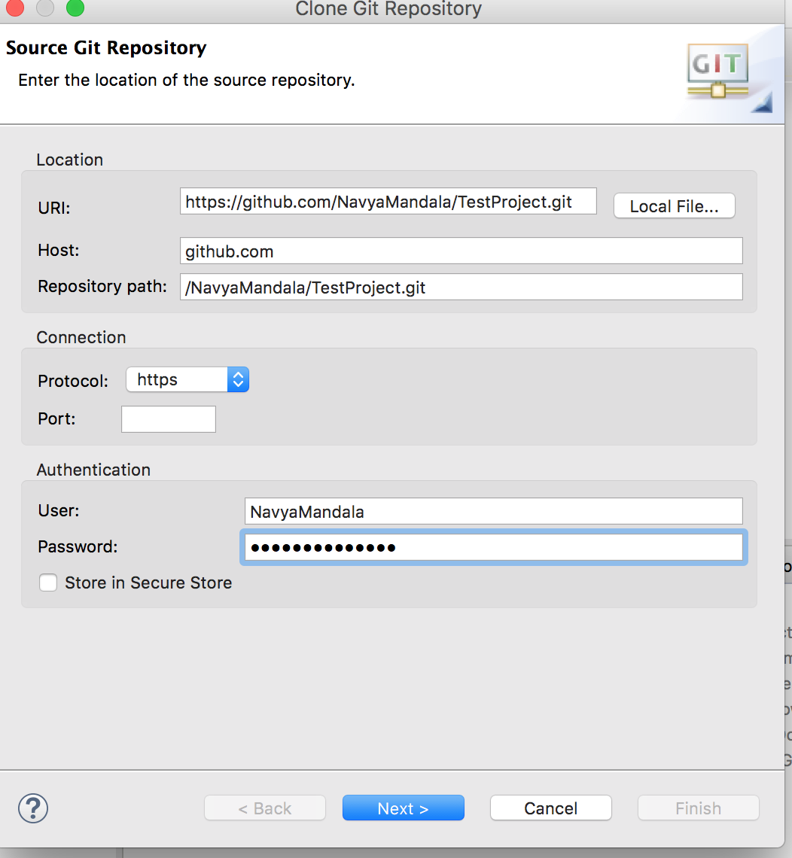

Click on next next and click on finish.

1. Create a project in eclipse and add that project to github
2. Right click on the project Teams->Share project and select github project
3. Commit and push the changes